The Agent Identity Manager (AIM): Accumulating Trust for AI Agent Authentication

Authors Anonymized

Abstract—The rapid spread of autonomous AI agents based on large language models (LLMs) has highlighted the lack of an infrastructure that can reliably authenticate these agents. Existing authentication mechanisms (API keys, OAuth, JWT) depend on central servers, carry single point of failure risk and do not provide a standard mechanism for agent-to-agent authentication. Cryptographic accumulators, on the other hand, are a mature cryptographic primitive for set membership verification but have not yet been applied to AI agent authentication. In this work, we propose the Agent Identity Manager (AIM) framework, which uses a multiple cuckoo filter-based cryptographic accumulator architecture. AIM is supported by a dedicated application layer protocol (AIM Protocol) that standardizes agent registration, verification, revocation and synchronization operations. Accumulating the same agent identities into multiple filters with different hash functions reduces the combined false positive rate. The inherent false positive risk of this data structure is managed through a two-stage verification strategy (fast local check and central exact verification for critical operations). This work presents the first system architecture applying symmetric accumulator data structures to AI agent authentication, with feasibility evaluations demonstrating its practical viability and establishing a foundational starting point for future research.
Keywords— AI agent authentication, cryptographic accumulator, cuckoo filter, multi-agent systems

Introduction
Autonomous AI agents based on large language models (LLMs) are spreading rapidly across a broad range of domains, from software development to customer service and from financial analysis to scientific research. Frameworks such as LangChain [1], AutoGen [2] and CrewAI [3] facilitate the development of multi-agent systems in which multiple agents work in coordination and significantly accelerate the industrial adoption of such systems. However, this rapid growth has also brought with it a critical infrastructure gap: no mechanism exists to reliably verify whether an agent actually has the identity it claims, whether it is authorized and whether its access can be instantly revoked when needed.
Industry reports reveal the scale of the identity and access gap with concrete data. According to Gartner's projections, by the end of 2026, 40% of enterprise applications will include task-specific AI agents, up from less than 5% in 2025 [4]. At the same time, a survey conducted by the Cloud Security Alliance in January 2026 with 228 IT and security professionals showed that 68% of organizations are unable to distinguish AI agent activity from human activity and that 74% grant their agents more access privileges than necessary [5]. According to another survey carried out by the same organization between September and October 2025 with 285 participants, only 21% of organizations are able to maintain a real-time inventory of their agents and 84% believe they would fail a compliance audit focused on agent behavior [6]. These data demonstrate that agent identity management is no longer a theoretical discussion but has become an urgent operational requirement.
At the root of this problem lie the architectural shortcomings of existing authentication mechanisms. Common approaches such as static API keys, OAuth tokens and JWT (JSON Web Token) are designed for human users and traditional software services. These mechanisms depend on a central server for every authentication operation; this both creates a single point of failure risk and leads to scalability issues as the agent population grows. More importantly, there is no standard mechanism for agent-to-agent authentication, in which two agents can verify each other without consulting a central authority.
In addressing these shortcomings, cryptographic accumulators, which enable verification of set membership through a compact proof, emerge as a promising alternative. The first cryptographic accumulator was proposed by Benaloh and De Mare [7] in 1993. This data structure has been successfully applied in areas such as certificate revocation [8] and anonymous authentication [9] in various forms including RSA accumulators, Merkle trees and bilinear map-based constructions. However, our extensive literature review has revealed that cryptographic accumulators have not been evaluated in the context of AI agent authentication.
Protocols such as LDAP [10], OpenID Connect [11] and RADIUS [12], which are widely used in current authentication systems, operate based on centralized identity providers and create latency and bandwidth issues as the number of users grows. To overcome this problem, Çekiş et al. [13] proposed an edge authentication protocol that shifts the verification process from the central server to edge devices and provides O(1)-complexity authentication based on a cryptographic accumulator. On another front, working to extend the accuracy boundaries of probabilistic data structures, Medury et al. [14] designed a structure that applies a cascading algorithm to cuckoo filters and provides zero-false-positive membership testing in cases where all potential false positives are known. The proposed AIM framework builds on the foundations laid by these two studies: it extends the vision of accumulator-based distributed authentication [13] into the AI agent ecosystem, while adapting the multiple cuckoo filter architecture [14] to reduce the false positive rate multiplicatively.
This study proposes the Agent Identity Manager (AIM) framework for AI agent authentication, leveraging a cryptographic accumulator architecture based on multiple cuckoo filters. AIM offers a balanced architecture between a central identity authority and agent-side multi-filters. At the core of the system lies the concept of accumulating identical agent identities across multiple cuckoo filters [15] using pairwise independent hash functions. Assuming the filters are independent and identically distributed (i.i.d.), while the false positive rate of a single filter is ε, the combined false positive rate across k filters decreases to εᵏ. For critical operations, a secondary verification can be conducted against the authoritative registry (Agent Registry) on the AIM server. This mechanism prevents potential false positives from resulting in actual unauthorized access. Furthermore, distributing filter replicas to each agent enables registration and revocation status queries to be executed with zero network round-trips, thereby minimizing dependency on the central authority.
Decentralized verification offers three core structural benefits. First, it enhances availability: agents can continue authenticating one another even when the central authority is unreachable or during network partitioning events. Second, it increases system capacity: relying on a single authority that performs a central state query per verification creates a throughput ceiling that degrades, rather than scales, under high concurrent load. Third, it reduces per-interaction latency: requiring a distinct network round-trip for every interaction in a multi-agent workflow forces systems to rely on sampling-based verification rather than inspecting every message. This pressure is highlighted in wide-area network (WAN) environments, where centralized verification latency can reach the order of 100ms per interaction. These three structural benefits are quantitatively measured in the Experimental Evaluation section.
The AIM framework standardizes registration, verification, revocation, and filter synchronization operations through a custom application-layer protocol (AIM Protocol). This study contributes by defining a system architecture that applies a multi-Cuckoo filter-based accumulator structure to AI agent authentication, coupled with a verification workflow based on signing requests with a private key and inspecting public key fingerprints within the filters. Furthermore, it presents the empirical results obtained from feasibility and conformance testing conducted on critical components of this architecture.
The remainder of this paper is organized as follows: Section II reviews prior literature; Section III introduces cuckoo filters and cryptographic accumulators; Section IV details the technical specifications of the AIM framework and its protocol; Section V describes the experimental setup and results of the feasibility tests. Finally, Section VI evaluates the findings, while Section VII establishes the trajectory for future research.

Related Works
This section presents the state of the art in three main research areas related to the proposed work: AI agent security and identity management, authentication applications of cryptographic accumulators and the use of cuckoo filters in the security domain. After evaluating the current state of each area, the literature gap at the intersection of these fields is presented.
AI agent identity management has become a rapidly developing area at both academic and industrial levels since 2024. Chan et al. [16] discussed agent identifiers, real-time monitoring and activity logging mechanisms aimed at improving the visibility of AI agents; the same group's “IDs for AI Systems” work [17] proposed a conceptual framework for assigning identities to AI system instances. In terms of cryptographic approaches, Rodriguez Garzon et al. [18] presented the first working prototype that provides self-sovereign identity by assigning W3C DIDs and Verifiable Credentials to AI agents; they demonstrated technical feasibility through LangChain and AutoGen integration but also revealed the limitations of an LLM managing security procedures on its own. AgentCrypt [19] proposed a four-layer privacy framework based on homomorphic encryption for agent-to-agent communication. On the industry side, the OWASP Agentic AI Top 10 (December 2025) established the first systematic risk taxonomy for autonomous agents and identified identity abuse as one of the main risk categories [20]; NIST NCCoE is running an active project titled “Software and AI Agent Identity and Authorization” [21]. Microsoft's Agent Governance Toolkit (April 2026) includes DID-based Ed25519 cryptographic identity and the Inter-Agent Trust Protocol [22], but it relies on traditional PKI primitives.
While the majority of these approaches rely on traditional cryptographic infrastructures, cryptographic accumulators, which enable verification of set membership through a compact proof, offer a lighter and more distributable alternative in the authentication domain. Since their introduction by Benaloh and De Mare [7] in 1993 as one-way accumulators, these structures have been applied in various authentication scenarios. Camenisch and Lysyanskaya [9] defined dynamic accumulators, enabling element addition/deletion at a cost independent of set size and membership verification through zero-knowledge proofs. Ren et al. [23] systematically examined the evolution of accumulator schemes; Özçelik et al. [24] presented a symmetric and asymmetric classification of accumulators and comparatively analyzed the space, time complexity and communication cost of each structure. Loporchio et al. [25] evaluated accumulator applications in blockchain systems. In terms of authentication applications, Özçelik and Skjellum [8] used RSA accumulators for blockchain-based distributed certificate revocation in their CryptoRevocate work; DA³4FL [26] combined dynamic accumulators with blockchain for authentication purposes in federated learning environments. More recently, Çekiş et al. [13] proposed a cryptographic accumulator-based edge authentication protocol. This study uses an ECC-based dynamic asymmetric accumulator to shift the verification process from the central server to edge devices and provides O(1)-complexity authentication. In the protocol design, finite state machines and sequence diagrams are used to formally model the system. However, this work does not target the AI agent ecosystem and carries the witness management cost arising from the use of an asymmetric accumulator. Our proposed AIM framework shares a similar distributed authentication vision but offers a different approach: through its choice of a symmetric accumulator (cuckoo filter), it requires no witnesses, supports deletion and reduces the false positive rate multiplicatively through a multiple filter architecture.
Cuckoo filters, which stand out within the symmetric accumulator class, have been preferred in authentication particularly in environments with scalability and low-latency requirements. Fan et al. [15] proposed this structure in 2014 as a practical alternative to Bloom filters. The authentication applications of cuckoo filters have predominantly concentrated on vehicular networks: Cui et al. [27] designed a privacy-preserving authentication protocol with their SPACF scheme; Li et al. [28] demonstrated the deletion advantage of cuckoo filters in pseudonym certificate revocation; Xenakis et al. [29] extended the 5G-AKA protocol with cuckoo filters to improve batch authentication efficiency. In the healthcare domain, Moni and Gupta [30] performed mutual anonymous authentication with a dual positive-negative cuckoo filter architecture in remote patient monitoring networks and provided formal verification with AVISPA. While all of these works demonstrate the effectiveness of cuckoo filters in authentication, they all target traditional network environments such as VANET, 5G and IoMT.
Our extensive review revealed no existing studies that apply cryptographic accumulators or probabilistic data structures within the context of AI agent authentication. Although current AI agent identity solutions (such as DID+VC [18], zero-knowledge virtual machines, and OAuth extensions) provide deterministic cryptographic verification, they rely on a centralized component to query identity validity and revocation status. Consequently, if this central component becomes unreachable, verification halts entirely; moreover, as the number of agents scales, relying on a single authority creates a severe performance bottleneck. While Cuckoo filters have been successfully deployed in VANET and IoMT environments, they have not yet been evaluated in AI agent scenarios. The present study directly addresses this research gap.

Background
This section outlines the general concept of cryptographic accumulators alongside their specific implementation as cuckoo filters.

Cryptographic Accumulators
A cryptographic accumulator is a space- and time-efficient data structure that represents the elements of a set with a single fixed-size value and enables membership in this set to be verified efficiently [24]. The core idea is to accumulate the elements of a set A = {y₁, y₂, ..., yₙ} into a small value z, where only set members can be proven to have been accumulated [31].
Cryptographic accumulators can be divided into two main classes: symmetric and asymmetric [24]. Symmetric accumulators are built on symmetric cryptographic primitives and can verify set membership directly without requiring a witness [32]. Bloom filters [33] and cuckoo filters [15] fall into this class; they store element fingerprints in an array structure using k hash functions and allow O(1)-complexity queries. However, they can produce false positives, meaning they may incorrectly report an element that is not in the set as a member. Asymmetric accumulators, on the other hand, are built on asymmetric cryptographic primitives and quasi-commutative hash functions [7]. RSA accumulators [7], bilinear map-based constructions [34] and Merkle trees [35] belong to this class. In these structures, a witness value is generated for each element and verification is performed as Ver(k, z, yᵢ, wᵢ) → {TRUE, FALSE} [31]. They do not produce false positives but witness generation and updating carry computational cost.
Accumulators are also classified by the operations they support: dynamic accumulators efficiently support element addition and deletion [9], while static structures do not support these operations. By the type of membership proof, positive accumulators support only membership, negative accumulators support only non-membership and universal accumulators support both proof types [24], [36]. In this study, cuckoo filters from the dynamic and positive symmetric accumulator class are preferred.

Cuckoo Filters
The cuckoo filter is a probabilistic data structure proposed by Fan et al. [15] in 2014 that performs approximate membership queries. The structure consists of a bucket array based on the cuckoo hashing principle [15]. Each element is represented by an f-bit fingerprint placed in one of two possible bucket positions. When an element is being inserted, if the primary bucket is full, the existing element is moved to its secondary bucket. This is the displacement mechanism of cuckoo hashing, which optimizes space efficiency [24]. During a query, the two possible buckets of the element are checked for the presence of its fingerprint. If there is no match, the element is definitely not in the set; if there is a match, the element is likely to be in the set.
The false positive rate of a single cuckoo filter is determined by the fingerprint length f and the number of entries per bucket b. For an f-bit fingerprint and a bucket structure with b = 4 entries, this rate is approximately expressed as [15]:
ε ≈ 2b/2^{f} (1)
Fan et al. [15] experimentally showed that, for a given number of elements, the cuckoo filter offers a lower false positive rate and space cost compared to the space-optimized Bloom filter. Unlike Bloom filters, cuckoo filters are not static accumulators; they support element deletion [24]. Bloom filters, on the other hand, are static accumulators: because multiple elements share the same bit positions, element deletion is not directly possible and requires the entire filter to be rebuilt [24], [33].
In the multiple filter approach proposed in this study, the same set of elements is added to k independent cuckoo filters using different hash functions. Since a match in all k filters is required for an element to be considered valid, the combined false positive rate is:
ε_{combined} ≈ ε^{k} (2)
This multiplicative reduction rests on the assumption that the false positive events of the filters are independent and identically distributed (i.i.d.) for independent events, the joint probability is equal to the product of their individual probabilities. Consequently, this reduction enables the combined rate to drop to 10⁻⁶ when k = 3 filters are used with a single-filter rate of ε = 0.01. The primary rationale for selecting cuckoo filters in the context of AI agent authentication lies in their combined advantages. Specifically, their deletion support eliminates the need to rebuild the filter when revoking an agent's authorization, their compact size allows copies to be distributed to the agent side for local verification, and they offer an O(1) complexity query time.

System Design

Working Principle
At the core of the AIM framework lies a multiple cuckoo filter-based accumulator structure. The working principle of this structure is shown in Fig. 1.
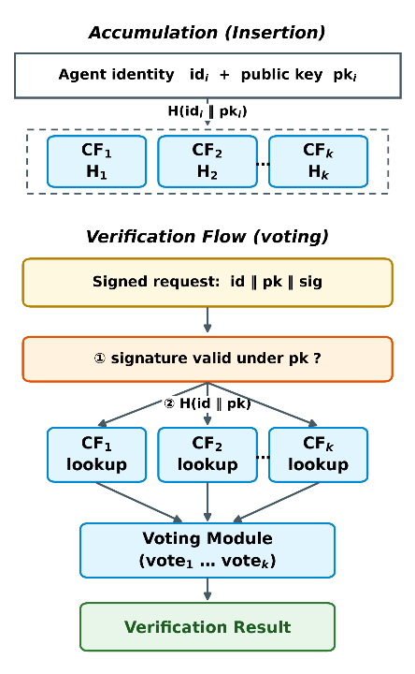
- Working principle of the multiple cuckoo filter-based accumulator.
In the system, each registered agent ID is added to k independent cuckoo filters with different hash functions (H₁, H₂, ..., Hₖ). During the verification process, the queried agent_id is evaluated through the multiple filter structure, and the combined output of the filters forms the basis of the verification decision.
The main advantage of this multiple filter strategy is the multiplicative reduction of the false positive rate. If the false positive rate of a single cuckoo filter is ε and k independent filters are used, the probability of a simultaneous false positive across all filters becomes εᵏ. A key structural advantage of the cuckoo filter over the Bloom filter [33] is that it natively supports element deletion [15], [24]. This feature is critically important in agent revocation scenarios: the ID of a revoked agent can be deleted from all filters in O(1) time without the need to rebuild the filter.

System Components
The AIM framework consists of four main components. These components and the interactions between them are shown in Fig. 2.
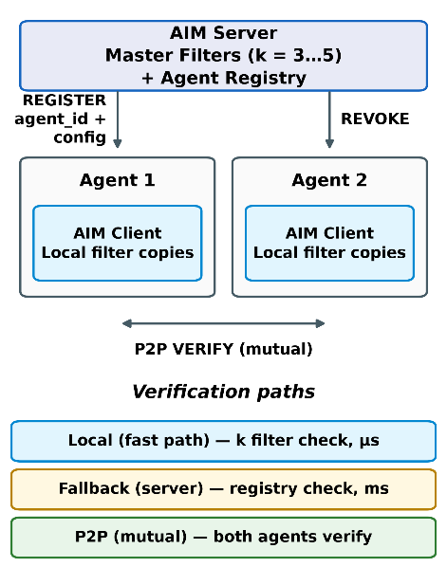
- AIM framework components and their connections.
AIM Server: This is the identity authority. It is responsible for agent ID generation, the management of master cuckoo filters (k filters) and the maintenance of the Agent Registry. All agent registration, revocation and filter synchronization operations are coordinated through this component.
Master Filters: These are k redundant cuckoo filters located on the AIM Server. Each one accumulates the same agent ID set using different hash functions. These filters are updated during registration and revocation operations, and their updated copies are distributed to all AIM Clients.
Agent Registry: This is the complete and exact database of all agent IDs. Since cuckoo filters are probabilistic structures, the registry is used as a fallback source in situations where exact verification is required (critical operations).
AIM Client: This is the client module embedded in each agent's runtime environment. It maintains a local copy of the master filters and performs verification operations. Verification is performed through the accumulators within the AIM Client, enabling fast verification without the need for network communication. In critical operations or in situations where local verification may be insufficient, the AIM Client can contact the central AIM Server to perform exact verification through the Agent Registry; this fallback mechanism allows the risk inherent to the probabilistic structure to be managed.

System Workflow
The system workflow can be examined in two main phases: registration and verification. This flow is shown as a sequence diagram in Fig. 3.
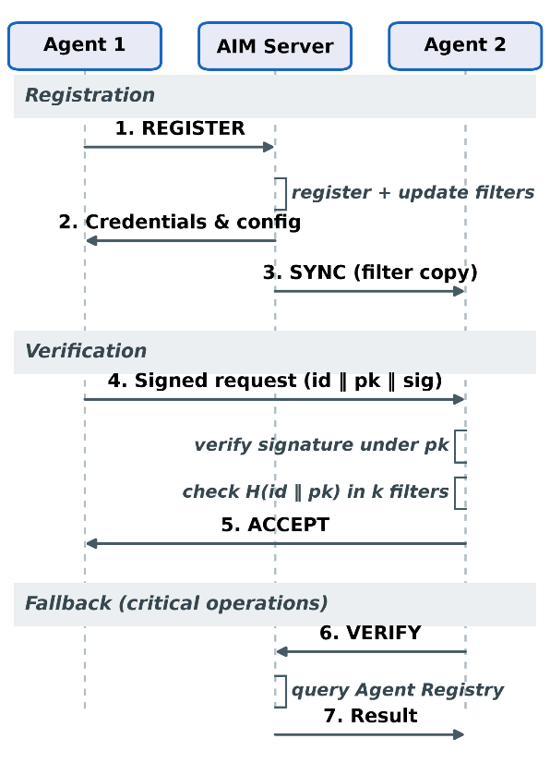
- AIM framework workflow.

Registration Flow
When a new agent is registered, it transmits a REGISTER request alongside its metadata to the AIM server. The server validates the request, generates a unique identifier, and records it in the Agent Registry. It then inserts this identifier into all k master filters utilizing distinct hash functions. Subsequently, the server returns the required credentials and configuration parameters, enabling the agent to participate in verification procedures. Finally, the updated filters are distributed to connected clients via a synchronization mechanism to ensure system-wide consistency among local copies.

Verification Flow
Local Verification (Flow 1): To authenticate its identity, the agent signs its request using its private key and appends its agent_id and public key to the request. The verifying agent's AIM Client first validates the signature against the provided public key to establish that the request originated from the key holder. Subsequently, it searches across all k local filters for the fingerprint of the identity and public key. An acceptance decision is generated if and only if the signature is valid and all filters cast an affirmative vote; a single negative vote from any filter suffices to reject the request. Because the workflow requires no network communication, registration and revocation status queries are completed without consulting a central authority.
Central Fallback (Flow 2): In critical operations (sensitive data access, highly privileged resources) or in situations where local verification may be insufficient, the AIM Client sends a VERIFY message to the central AIM Server. The AIM Server performs an exact check against the Agent Registry and completes the verification with a challenge-response. This fallback mechanism makes it possible to manage the risk inherent to the probabilistic structure and to ensure reliability in scenarios that require exact verification.
An acceptance decision relies on the joint vote of k filters: a single negative vote from any filter is sufficient to reject the request, and such a negative vote is definitive. The transition of operations to the centralized path is governed by an application-configurable threshold based on the inherent risk of the operation. In the proposed design, operations are categorized into three classes: message ingestion and read-only calls are validated exclusively locally; operations that modify shared state are confirmed through centralized validation; and irreversible or high-privilege operations (such as credential access, data export, and financial transactions) are centrally validated under all conditions. Incorporating per-filter trust weights into the voting process has been deferred to future work.

AIM Protocol
The AIM Protocol is an application layer protocol that standardizes all communication between the server and clients. Operating over TCP sockets, each message consists of a JSON payload framed by a length prefix. The four primary operational messages are REGISTER, VERIFY, REVOKE, and SYNC; these are accompanied by SUBSCRIBE and INVALIDATE for synchronization subscriptions, CHALLENGE and RESPONSE for identity authentication, and ERROR for error reporting. During centralized authentication, the server generates a single-use nonce, and the agent proves possession of its private key by signing this nonce. Filter synchronization is achieved via a versioned pull mechanism: the client reports its current version, and the server transmits a state snapshot only when the client is out of date. Following revocation operations, the server triggers an update by broadcasting an INVALIDATE message containing only the new version number to subscribed clients. Finally, Transport Layer Security (TLS) serves as an optional security extension that can be integrated into the transport layer.

Experimental Evaluation

Experimental Setup and Methodology
The proposed architecture was evaluated through independent feasibility and compliance tests guided by three principles. First, for reproducibility, each test uses a fixed master seed and logs all parameters in the output file. Second, the measurement configuration was decoupled from the operational one. Because joint false positive events are virtually unobservable under strong fingerprints with feasible query volumes, metrics were measured on an intentionally degraded setup and structurally extrapolated to operational levels. Third, for a fair comparison, the same workload ran on a baseline system representing a centralized identity authority.
This baseline system performs JWT-based token verification via a standard library and handles revocation through a centralized denylist. This reflects JWT's true revocation overhead, which achieves immediate revocation by sacrificing stateless verification. Executed in-process on a single machine, the baseline captures purely computational overhead without network latency (discussed further under verification latency). Thus, results emphasize relative ratios and scaling behavior rather than absolute metrics.
We evaluated performance via a parameter sweep across agent population size (1,000 to 100,000), filter count (k ∈ {1, 2, 3, 5}), and fingerprint length (swept from weak bounds to standard widths). The proposed operational setup uses a 32-bit fingerprint determined solely by the target false positive rate. Addressing is managed separately by scaling the number of buckets with the agent population. Because verification overhead is independent of credential content, these parameters drive the measurements. Reported local latency includes AND voting across all k = 3 filters, while memory overhead is measured separately.

Hash Independence and Joint False Positive Rate
The framework assumes that stacking multiple filters exponentially reduces the false positive rate, a claim contingent on mutually independent false positive events across filters. If independence fails, the multiplication rule breaks down, rendering additional filters ineffective and leaving the architecture's core claim unsubstantiated; thus, measuring independence is central to the experimental testbed.
To assess this, three hashing schemes were evaluated: AIM's standard design using mutually independent keys, a common shortcut relying on sequential values of a single base seed (acting as a negative control), and a double hashing method derived from two base hashes.
Performance was captured through two complementary metrics: the ratio of the observed joint rate to theoretical predictions, where values near 1 confirm proper operation of the multiplication rule, and the φ-correlation coefficient of false positives between filter pairs, where values near 0 verify that errors do not co-occur. The complete results are illustrated in Figure 4.
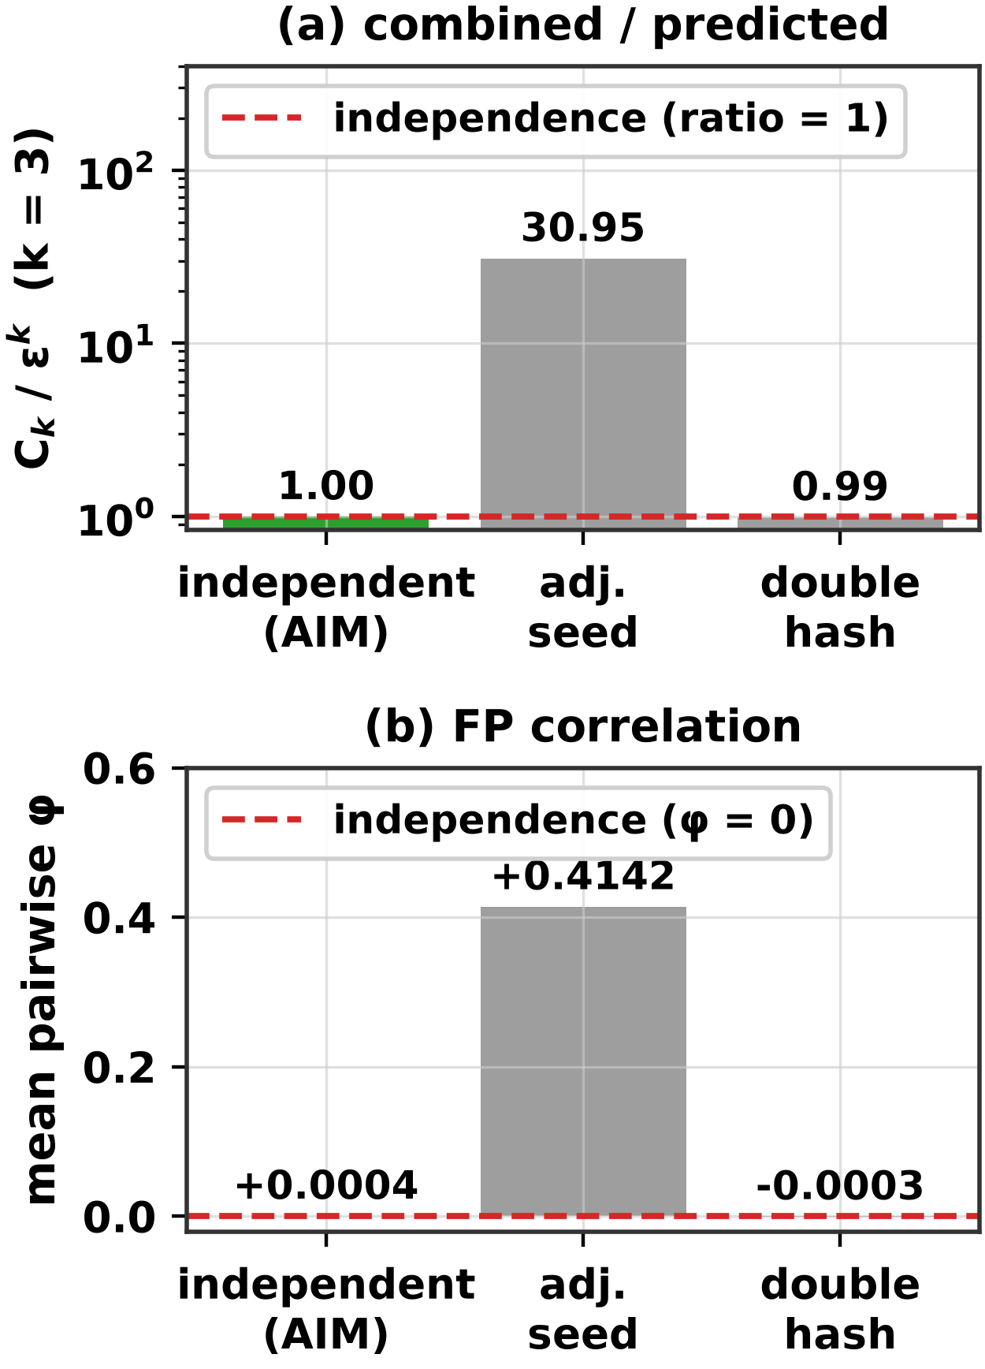
- Comparison of three hash configurations in terms of independence: (a) the ratio of the observed combined false positive rate to the independence prediction (k = 3; expected value 1), (b) the mean φ correlation between filter pairs (expected value 0). The setup on the left is the design used by AIM.
In AIM's independent setup, the observed combined rate aligns with theoretical independence within measurement precision, and pairwise φ-coefficients are indistinguishable from zero. Double hashing demonstrates identical behavior. Conversely, under the consecutive seed shortcut, the rate increases over thirtyfold, and the mean φ shifts significantly positive. In this configuration, filters duplicate errors, eliminating the protection expected from extra filters. Expressed as a gain over a single filter, three filters in the independent setup boost protection approximately seventy-five-fold, whereas the shortcut yields just over a two-fold gain. Thus, despite incurring the computational cost of three filters, protection remains virtually at single-filter levels. This negative control highlights a critical design rule: protection stems from filter independence, not filter count.
At the single-filter level, the empirical false positive rate also matches the theoretical prediction. For fingerprints up to 16 bits, the ratio of observed to predicted values stays within a 10% margin of 1, confirming practical validity. For longer fingerprints, measurability becomes the limiting factor. In the operational setting, zero false positive events were observed across millions of queries, as expected event frequencies fell far below the observation budget. Consequently, operational combined rates are reported as extrapolated results rather than measured values, while independence is evaluated in a relaxed setup where measurement is feasible.

Verification Latency and Network Round-Trip Cost
Effective risk management in two-stage verification requires a low-cost local path. Achieving central authority independence further requires zero network round trips. This section evaluates each verification path by computational cost and round-trip count. Figure 5 presents these path costs through measured baseline costs and a total latency projection.
The baseline measurements in Figure 5(a) are not directly comparable. Local AIM verification executes as an in-memory call without network operations. Similarly, JWT runs in-process, measuring only CPU cost for signature verification and revocation list checks without socket overhead. In contrast, central AIM was measured over an active connection, incurring transport overhead. Thus, the performance gap between central AIM and JWT stems from network measurement differences rather than algorithmic inefficiency. Meaningful comparisons must focus on network round trips.
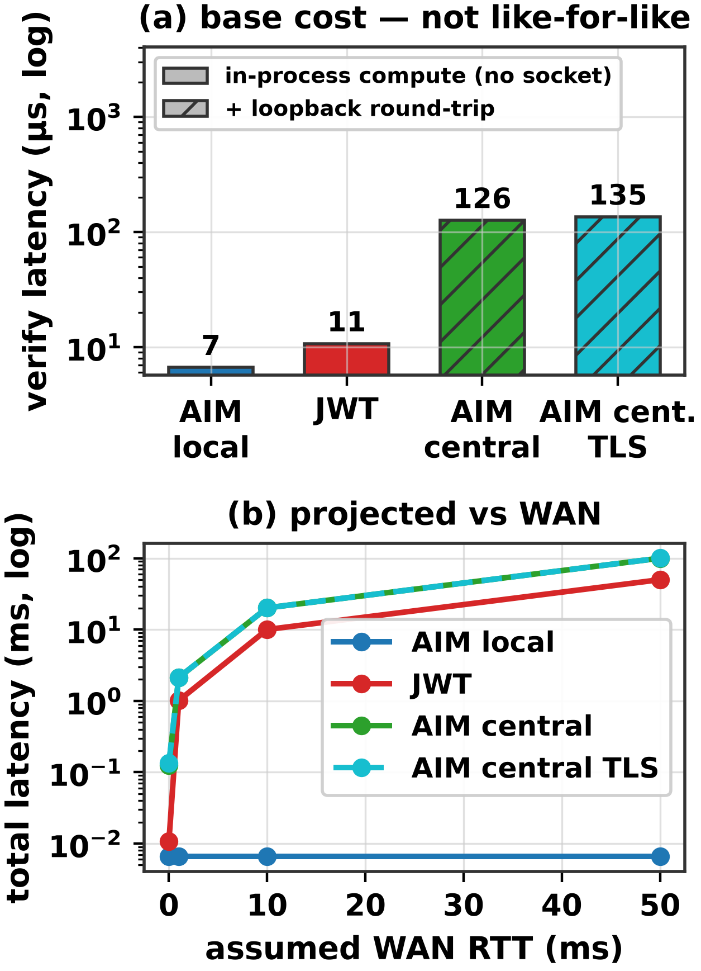
- Verification cost: (a) measured baseline costs; hatched bars include an actual socket round-trip, solid bars represent in-process computation only; (b) total latency projection as a function of the number of round-trips.
Round-trip count is the key differentiator where local verification requires zero, JWT requires one, and central AIM requires two. Central AIM uses two round trips for identity authentication via a challenge-response scheme, which protects the secret key from network exposure. This latency is acceptable because central AIM serves as an infrequent fallback mechanism rather than a hot path.
Figure 5(b) projects latency by adding measured baseline costs to the product of round trips and assumed round-trip time (RTT). The model assumes linear latency accumulation without significant bandwidth or packet loss impacts. At 50 ms RTT (representing a transcontinental deployment), local verification remains constant at the microsecond level. Meanwhile, single-round-trip paths rise to tens of milliseconds, and two-round-trip paths reach hundreds of milliseconds. In this regime, RTT dominates computational baseline differences. Additionally, central paths with and without TLS yield nearly identical results. Because handshake overhead occurs only once, using persistent connections renders per-verification TLS overhead negligible.

Memory Overhead and Resilience of the Multi-Filter Architecture
While empirical findings support the framework's core claims, the multi-filter architecture incurs a clear memory overhead. For short and medium fingerprint lengths, running k parallel filters costs roughly 20% more memory than an equivalently protected single filter. Thus, memory efficiency does not justify this design. The primary rationale for the multi-filter architecture is decentralized protection. If an adversary neutralizes a subset of k filters, attack success increases by roughly one order of magnitude per compromised filter. For k = 3, success rates rise from 0.2% with no breaches, to 1% with one breach, 10% with two, and total protection failure only when all three are breached. Single-filter designs lack this graceful degradation; a single breach eliminates all protection. Ultimately, the architecture is justified not by space efficiency, but by graceful degradation and the strict requirement that an adversary must compromise all independent filters simultaneously.

Comparative Summary
Table 1 compares AIM with a centralized identity authority across key characteristics under identical workloads. The advantage of AIM lies not in a single metric, but in the balance among criteria: while the local path eliminates central dependency and network round-trips, it is more costly than single-round token verification on the centralized path, and probabilistic verification carries an inherent risk absent in deterministic token verification.
Table 1. Comparison of AIM and a centralized identity authority under identical workloads.
Metric | AIM | JWT
Local verification | Microsecond level, no network round-trips | None (central authority required)
Centralized verification | 2 round-trips (challenge-response) | 1 round-trip
False positive model | ε^{k} consensus vote of k filters) | None (deterministic token)
Central dependency | Critical operations only | Every verification

Discussion and Conclusion
The rapid spread of LLM-based autonomous AI agents has highlighted the lack of an infrastructure that can reliably authenticate agents. Industry surveys reveal that the majority of organizations cannot distinguish agent activity from human activity and would fail compliance audits focused on agent behavior [5], [6]. Existing mechanisms such as static API keys, OAuth and JWT suffer from architectural shortcomings such as dependence on a central server, single point of failure risk and the lack of a standard mechanism for agent-to-agent authentication. Cryptographic accumulators, on the other hand, offer a mature primitive that enables verification of set membership through a compact proof, yet these structures have not been applied to AI agent authentication.
To address this research gap, Agent Identity Manager (AIM), a new framework for AI agent authentication is proposed and its empirical feasibility is tested. By combining a multi-cuckoo filter architecture, two-stage verification, and distributed filter replicas, AIM reduces false positive rates to εᵏ, mitigates probabilistic risk, and eliminates central dependencies for revocation status queries. Under the independence assumption, microsecond local verification occurs without a network round-trip. This design extends the distributed verification model of Çekiş et al. [13] to the AI agent ecosystem using the multi-filter approach of Medury et al. [14].
The results also reveal structural trade-offs. For short fingerprints, multi-filtering adds overhead compared to a single filter, though equivalent single-filter protection is practically infeasible. The architecture prioritizes graceful degradation and resilience against offline exhaustive searches over space efficiency. Additionally, two-round challenge-response verification is costlier than single-round token verification, but remains acceptable for an infrequently used fallback mechanism. Finally, tests focused on identity primitives in the authentication layer rather than live LLM-based autonomous agents; measuring total verification overhead in full agent workflows is left for future work.

Ongoing and Future Work
Future work will transition AIM from synthetic identity benchmarks into operational multi-agent systems. Integrating AIM into standard multi-agent environments will allow us to measure its exact verification overhead during runtime execution.
A primary security priority is establishing identity binding to the executing agent. Currently, keys are not tied to a specific agent instance, creating impersonation risks if compromised. To resolve this, we will implement runtime attestation via hardware security modules (such as TPM or secure enclaves), short-lived identities, and runtime signatures.
We will also expand the testbed under realistic agent workloads. This evaluation will measure the revocation latency window, tracking how long revoked agents remain erroneously valid before local filter replicas update.

References
- LangChain, “LangChain: Build context-aware reasoning applications,” 2024. [Online]. Available: https://www.langchain.com
- Q. Wu et al., “AutoGen: Enabling next-gen LLM applications via multi-agent conversation,” arXiv:2308.08155, 2023.
- CrewAI, “CrewAI: Framework for orchestrating role-playing autonomous AI agents,” 2024. [Online]. Available: https://www.crewai.com
- Gartner, Inc., “Gartner predicts 40% of enterprise apps will feature task-specific AI agents by 2026, up from less than 5% in 2025,” Press Release, Aug. 26, 2025.
- Cloud Security Alliance, “The identity and access gaps in the age of autonomous AI,” Survey Report, commissioned by Aembit, Mar. 2026.
- Cloud Security Alliance, “Securing autonomous AI agents,” Survey Report, commissioned by Strata Identity, Feb. 2026.
- J. Benaloh and M. de Mare, “One-way accumulators: A decentralized alternative to digital signatures,” in Proc. EUROCRYPT ’93, Springer LNCS, vol. 765, 1993, pp. 274–285.
- İ. Özçelik and A. Skjellum, “CryptoRevocate: A cryptographic accumulator based distributed certificate revocation list,” in Proc. 11th IEEE CCWC, 2021, pp. 865–872.
- J. Camenisch and A. Lysyanskaya, “Dynamic accumulators and application to efficient revocation of anonymous credentials,” in Proc. CRYPTO 2002, Springer LNCS, vol. 2442, 2002, pp. 61–76.
- V. Koutsonikola and A. Vakali, “LDAP: Framework, practices, and trends,” IEEE Internet Comput., vol. 8, no. 5, pp. 66–72, 2004.
- D. Fett, R. Küsters, and G. Schmitz, “The web SSO standard OpenID Connect: In-depth formal security analysis and security guidelines,” in Proc. IEEE 30th CSF, 2017, pp. 189–202.
- S. Goldberg et al., “RADIUS/UDP considered harmful,” in Proc. 33rd USENIX Security, 2024, pp. 7429–7446.
- İ. K. Çekiş, A. Toros, V. Yiğit, and İ. Özçelik, “Edge authentication using a cryptographic accumulator,” in Proc. 2025 9th Int. Symp. Multidisciplinary Studies and Innovative Technologies (ISMSIT), IEEE, 2025, pp. 1–5.
- S. Medury, A. Altarawneh, and A. Skjellum, “Design and evaluation of cascading cuckoo filters for zero-false-positive membership services,” in Proc. 11th IEEE CCWC, 2021, pp. 1061–1065.
- B. Fan, D. G. Andersen, M. Kaminsky, and M. D. Mitzenmacher, “Cuckoo filter: Practically better than Bloom,” in Proc. 10th ACM CoNEXT, 2014, pp. 75–88.
- A. Chan et al., “Visibility into AI agents,” in Proc. ACM FAccT ’24, 2024, pp. 958–973.
- A. Chan et al., “IDs for AI systems,” arXiv:2406.12137, 2024.
- S. Rodriguez Garzon et al., “AI agents with decentralized identifiers and verifiable credentials,” arXiv:2511.02841, 2025.
- H. Karthikeyan et al., “AgentCrypt: Advancing privacy and secure computation in AI agent collaboration,” in Proc. NeurIPS, 2025.
- OWASP, “Top 10 for Agentic Applications 2026,” Dec. 2025. [Online]. Available: https://genai.owasp.org
- R. Galluzzo, B. Fisher, H. Booth, and J. Roberts, “Accelerating the adoption of software and AI agent identity and authorization,” NIST NCCoE Concept Paper, Feb. 2026.
- Microsoft, “Agent Governance Toolkit,” GitHub, MIT License, Apr. 2026. [Online]. Available: https://github.com/microsoft/agent-governance-toolkit
- Y. Ren, X. Liu, Q. Wu, L. Wang, and W. Zhang, “Cryptographic accumulator and its application: A survey,” Security and Communication Networks, vol. 2022, Article 5429195, 2022.
- İ. Özçelik, S. Medury, J. Broaddus, and A. Skjellum, “An overview of cryptographic accumulators,” in Proc. 18th Int. Conf. Security and Cryptography (SECRYPT), 2021, pp. 661–668.
- M. Loporchio, A. Bernasconi, D. Di Francesco Maesa, and L. Ricci, “A survey of set accumulators for blockchain systems,” Computer Science Review, vol. 49, Article 100570, 2023.
- DA³4FL authors, “DA³4FL: A robust dynamic accumulator-based authentication and key agreement with preserving model training data integrity for federated learning,” Nature Scientific Reports, Article s41598-025-33685-1, 2025.
- J. Cui, J. Zhang, H. Zhong, and Y. Xu, “SPACF: A secure privacy-preserving authentication scheme for VANET with cuckoo filter,” IEEE Trans. Veh. Technol., vol. 66, no. 11, pp. 10283–10295, 2017.
- Li et al., “Improving efficiency of pseudonym revocation in VANET using cuckoo filter,” in Proc. IEEE Conf., 2020.
- C. Xenakis et al., “Lightweight and space-efficient vehicle authentication based on cuckoo filter,” in Proc. IEEE Conf., 2020.
- S. S. Moni and D. Gupta, “Secure and efficient privacy-preserving authentication scheme using cuckoo filter in remote patient monitoring network,” in Proc. IEEE TPS-ISA, 2022, pp. 208–216.
- N. Fazio and A. Nicolosi, “Cryptographic accumulators: Definitions, constructions and applications,” Technical Report, New York University, 2002.
- A. Kumar, P. Lafourcade, and C. Lauradoux, “Performances of cryptographic accumulators,” in Proc. 39th Annual IEEE Conf. Local Computer Networks, 2014, pp. 366–369.
- B. H. Bloom, “Space/time trade-offs in hash coding with allowable errors,” Communications of the ACM, vol. 13, no. 7, pp. 422–426, 1970.
- C. Tartary, S. Zhou, D. Lin, H. Wang, and J. Pieprzyk, “Analysis of bilinear pairing-based accumulator for identity escrowing,” IET Information Security, vol. 2, no. 4, pp. 99–107, 2008.
- R. C. Merkle, “A certified digital signature,” in Proc. Conf. Theory and Application of Cryptology, 1989, pp. 218–238.
- J. Li, N. Li, and R. Xue, “Universal accumulators with efficient nonmembership proofs,” in Proc. ACNS, 2007, pp. 253–269.

